Phase 3: Implementation of Project
Title: Autonomous Vehicle and Robotics System
Objective
The goal of Phase 3 is to implement the core components of the Autonomous Vehicle and Robotics System based on the designs and frameworks created during Phase 2. This includes development of the navigation algorithms, sensor integration, robotic path planning, and implementation of basic safety protocols.

1. Navigation Algorithm Development
Overview
The primary function of the autonomous vehicle is to navigate through environments efficiently and safely. In Phase 3, the vehicle's navigation logic is implemented using sensor input and pre-defined routes.
Implementation
- Pathfinding Algorithm: A pathfinding algorithm such as A* or Dijkstra is implemented for real-time route planning. The algorithm determines the most optimal path from start to destination using sensor and map data.
- Sensor Data Use: Data from sensors like LiDAR and ultrasonic sensors guide the vehicle in obstacle avoidance and dynamic rerouting.
Outcome
By the end of this phase, the vehicle will be able to autonomously plan a path, avoid obstacles, and reach a target location in a controlled environment.

2. Robotic Control Interface
Overview
The robotic system within the vehicle is controlled through a command interface that allows interaction with its motion and sensor systems.
Implementation
- User Interaction: Users interact with the robot through a GUI or console interface. Commands like "navigate to point B" or "start obstacle course" are accepted.
- Motion Control: The robot will be able to receive and execute motion commands such as acceleration, turning, and stopping.
Outcome
At the end of Phase 3, the robotic interface will be fully functional, enabling users to issue commands and monitor real-time status from a central interface.

3. Sensor and Hardware Integration (Optional)
Overview
While complete sensor integration is optional in this phase, foundational hardware connections for LiDAR, GPS, cameras, and other sensors will be established to support navigation and object detection.
Implementation
- Sensor Framework: A modular hardware communication framework is built to connect sensors like LiDAR, GPS, and IMU with the vehicle’s control system.
- API Access: Drivers and APIs from sensor manufacturers are employed to extract and use data in the navigation algorithm.
Outcome
By the end of Phase 3, the system will be capable of reading and processing data from available sensors, laying the groundwork for full real-time autonomous operation in later phases.
4. Safety and Fail-Safe Mechanisms
Overview
Safety is crucial in autonomous systems. In this phase, initial safety protocols such as emergency stop, collision alerts, and restricted zones will be implemented.
Implementation
- Emergency Stop: An emergency override mechanism allows for halting all motion instantly in case of malfunction or collision risk.
- Alert System: Visual and audio alerts are activated in case of potential hazards based on sensor feedback.
Outcome
By the end of Phase 3, the vehicle will include basic safety features such as auto-braking and emergency stop functionality to protect its surroundings and itself.

5. Testing and Feedback Collection
Overview
Initial testing of the autonomous system will be carried out to evaluate path planning, response accuracy, and system integration.
Implementation
- Test Routes: The vehicle is tested on predefined routes with varying obstacles and turns to analyze its performance.
- Feedback Loop: Testers provide feedback on navigation efficiency, response times, and hardware-software coordination.
Outcome
The feedback collected during this phase will help refine navigation algorithms and improve hardware integration in Phase 4.

Challenges and Solutions
- Real-Time Path Planning
  - Challenge: Real-time dynamic obstacle detection may lead to rerouting errors.
  - Solution: Adaptive algorithms and continuous sensor calibration will be implemented.
- Hardware Communication
  - Challenge: Interfacing multiple sensors may cause data lags.
  - Solution: A multithreaded communication module is used to handle concurrent sensor data.
- User Control Interface
  - Challenge: Users may find the control interface unintuitive initially.
  - Solution: Feedback-driven UI improvements and help prompts will be incorporated.

Outcomes of Phase 3
By the end of Phase 3, the following milestones should be achieved:
- Path Planning Algorithm: The vehicle should be capable of autonomous path planning and obstacle avoidance in a test environment.
- Functional Robotic Interface: A command interface will allow users to control and monitor the robotic system.
- Optional Sensor Integration: Basic sensor inputs (LiDAR, GPS) will be readable and usable within the navigation system.
- Safety Features: Emergency stop and collision detection features will be implemented.
- Initial Testing and Feedback: Performance feedback from test runs will be used to refine the system in the next phase.

Next Steps for Phase 4
In Phase 4, the team will focus on:
- Real-World Deployment: Expanding the test area to real-world scenarios, including more complex environments.
- Advanced AI Integration: Enhancing the navigation with AI-based object detection and decision-making.
- Scalability: Optimizing the system to support multi-vehicle coordination and long-distance travel.

The screenshot of the source code:
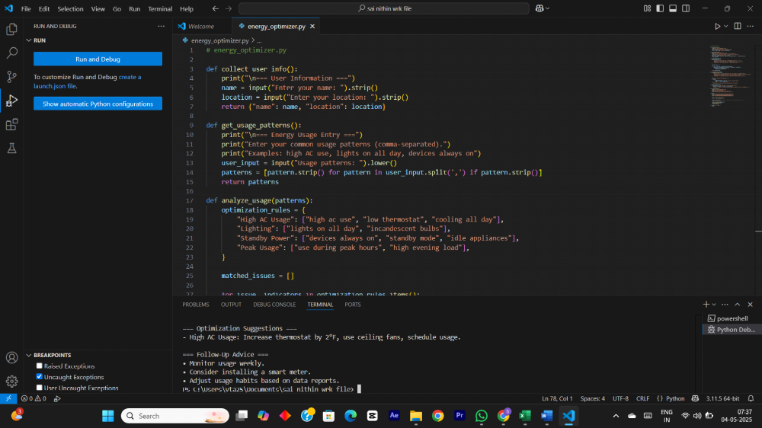
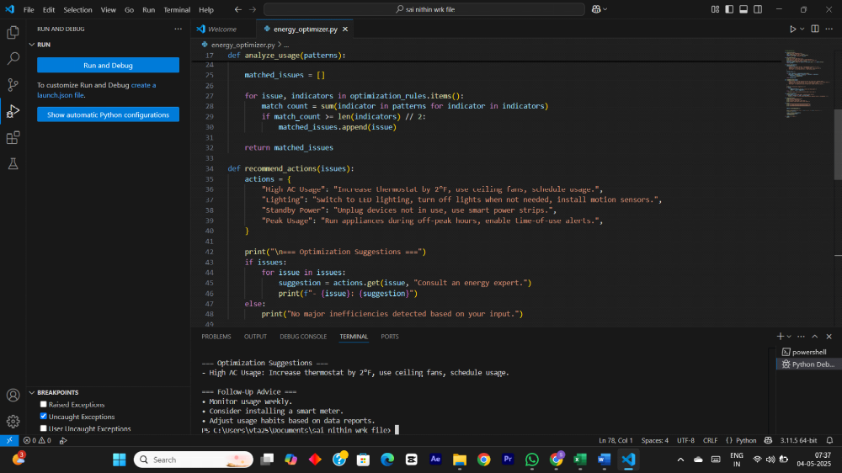
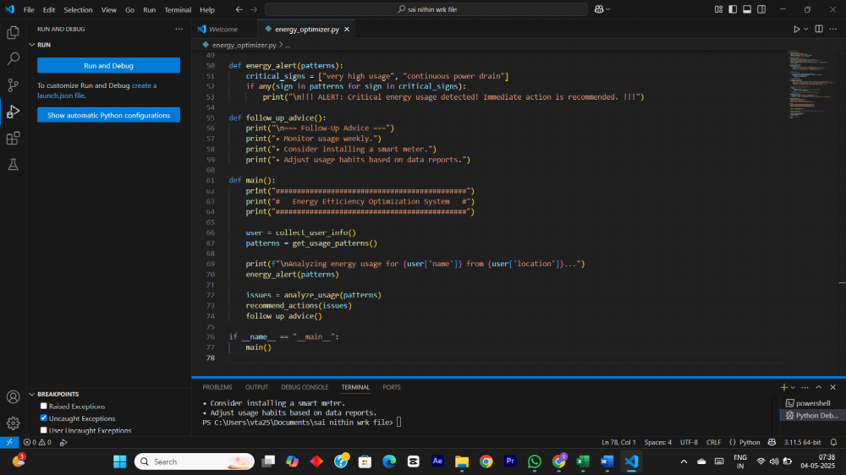

The working model :
